Level-6

Final Project

Job Advertisement

By

Iqbal Singh

Table of Contents

Project Proposal 3

Goals and Objectives 3

Project Scope 3

Project Specifications 3

Target Audience 3

Project Deliverables 4

Resource Requirements 4

Project Tasks and Milestones 4

Project Assumptions 5

Project Report 5

Detail Design 6

Home Page 6

Login Page 6

Admin Advertisements Page 7

Admin Applicant Page 8

Admin Application list Page 9

User Advertisement Page 10

User Detail Page 11

Job Application list Page 12

Project Testing 13

Usability Testing 13

Testing 13

User Manual 16

System Summary 16

System Configuration 16

User Access Levels 16

# 

# Project Proposal

## Goals and Objectives

The main goal of this project is to implement an online web application named job advertisement. This web application will help to locate the available jobs and users can apply for these jobs in their own time. In this application there is admin and users. Admin has the right to edit, delete advertisements and add new advertisements whenever possible. Further admin can create new applicants, edit existing ones, delete them and check the details. Admin can also delete and check details of various job applications. Moreover, user can view job advertisements and apply for the selected jobs. Also, user can delete job application and can check the details for the job applications. Both admin and user can login to the system by using their credentials.

## Project Scope

The duration for the project is 4 weeks which is around 20 days. The scope of the project is to implement an online web application named job advertisement. This web application will help to locate the available jobs and users can apply for these jobs in their own time.

## Project Specifications

* Login by admin and users
* Add, edit and delete advertisements by admin
* Admin can add, edit, delete and check details of the applicants
* Admin can delete and check details for the job applications.
* User can view job advertisements and can apply for the jobs.
* User can view the job applications also can delete it.

## Target Audience

The audience for this project will be the graduates and the people who are looking for jobs. Age group can start from 16 and can go up to 65plus or more.

## Project Deliverables

Following table states the deliverables for the project:

|  |  |
| --- | --- |
| **Deliverable** | **Description** |
| Final Report | This will be the final complete report of the project |
| Coding | All the code of the project will go in this part. |
| Documentation | This will show how the application will run and the user manuals |
| Testing | This part will highlight the test details of the project. |

## Resource Requirements

Following technologies and development method:

* Identity framework- ASP
* Windows Operating System
* Asp.net MVC Framework
* 64-bit Processor and 8 GB or more RAM

## Project Tasks and Milestones

The table below shows the Project Tasks and Milestones

|  |  |
| --- | --- |
| **Weeks** | **Tasks** |
| 1 | Brainstorming and Research |
| 1 | Planning and meeting & Consultation  proposal documentation. |
| 1 | Database Design- Plan and Implementation |
| 2 | Identity framework Implementation |
| 2 | Coding- Admin Part |
| 2 | Coding – User part |
| 3 | Testing |
| 4 | Final Documentation |

## Project Assumptions

Following are the assumption made while doing the implementation of the project:

* One admin and user exist while the App is designed and implemented.
* Admin can user needs to have valid credentials.
* Only admin can add new admin and manage the users of the application
* The app will be open sources and user friendly.

# Project Report

#### Functional and Non-Functional

The functional requirements and non-functional requirements of this project are as follows:

|  |  |  |
| --- | --- | --- |
| Users | Functional | Non- Functional |
| Admin | * Login/Logout * Manage advertisements * Create, edit, delete and check details of the applicants * Can check details and delete job applications | The non-functional requirements of the project are:   * The project will run on all browsers and devices. * The project will be secure * The load time will be fast * Admin will have full access of the system. * User will have limited access of the system. |
| Users | * Login/Logout * Signup * Can view job advertisements * Can apply job * Can view the job applications * Can delete job application |

## Detail Design

### Home Page

This is the main landing page of the application. On the navigation menu there are- home, Advertisements, Signup and Apply, Login and Register as Administrator are available.



### Login Page

With the help of this page registered admin and user can login to the system by using their valid credentials.

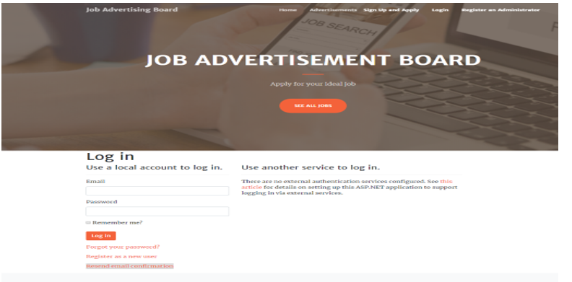

### Admin Advertisements Page

On this Page admin can add new advertisements, edit existing ones and also delete the expired ones and the ones that has been filled.



### Admin Applicant Page

With the help of this page, admin can manage the applicants of the application. For example- Admin can delete applicants and can check their details.



### Admin Application list Page

This page helps the admin to delete and check the details of the various application available on the application

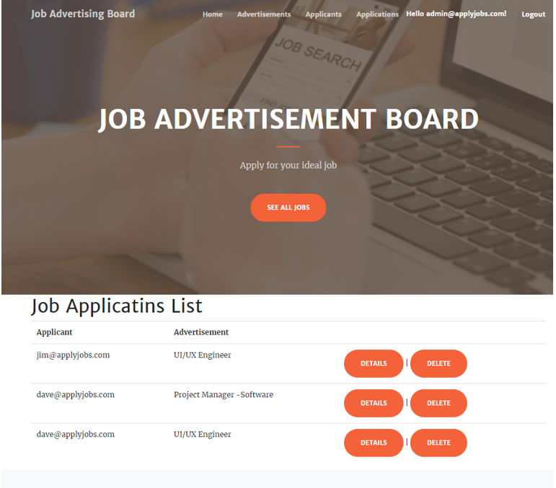

### User Advertisement Page

On this page user can view the advertisements for jobs and can apply for job of their choice.

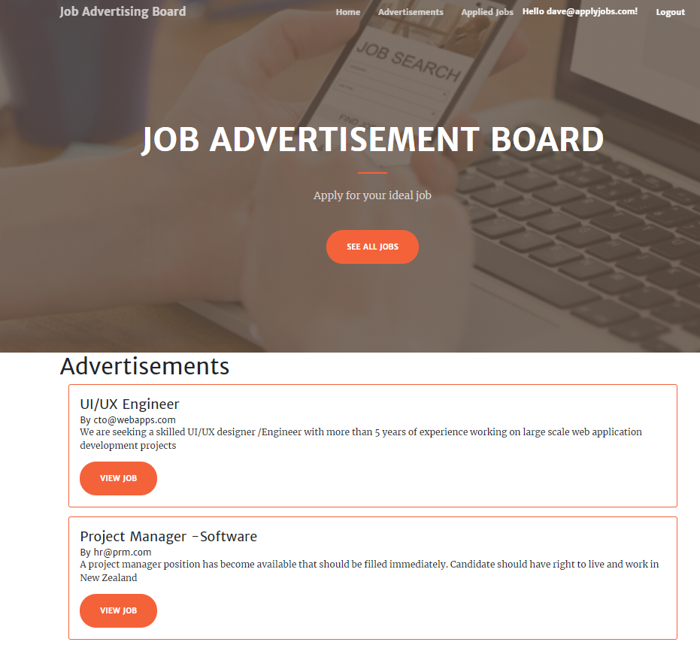

### User Detail Page

With the help of this page, user can see the details of various jobs available.



### Job Application list Page

This page will help the user to see the list of application , also user can delete the applications.



# Project Testing

## Usability Testing

### Testing

|  |  |  |
| --- | --- | --- |
| **Tester – 1** | | **Scale** |
| **No.** | **Question** | **Good, very good, bad, neutral,** |
| 1 | Do you think you need the support of a technical person to use this system? | Good |
| 2 | Is there any inconsistency? | Very Good |
| 3 | Is system easy to use? | Good |
| 4 | I would like to use this system daily | Bad |
| 5 | Integration is good | Neutral |
| 6 | I found the system complicated | Good |
| 7 | I think most people would learn to use this system very quickly | Neutral |
| 8 | I found the system very challenging to use | bad |
| 9 | I can feel confident while running the system | Good |
| 10 | Lot of knowledge is required to run the system | Neutral |

**Tester 1**

**Tester 2**

|  |  |  |
| --- | --- | --- |
| **Tester – 2** | | **Scale** |
| **No.** | **Question** | **Good, very good, bad, neutral,** |
| 1 | Do you think you need the support of a technical person to use this system? | Good |
| 2 | Is there any inconsistency? | Good |
| 3 | Is system easy to use? | Good |
| 4 | I would like to use this system daily | Good |
| 5 | Integration is good | Neutral |
| 6 | I found the system complicated | Good |
| 7 | I think most people would learn to use this system very quickly | Good |
| 8 | I found the system very challenging to use | Netural |
| 9 | I can feel confident while running the system | Good |
| 10 | Lot of knowledge is required to run the system | Neutral |

# User Manual

The job Advertisement web application will help to locate the available jobs and users can apply for these jobs in their own time. In this application there is admin and users. Admin has the right to edit, delete advertisements and add new advertisements whenever possible. Further admin can create new applicants, edit existing ones, delete them and check the details. Admin can also delete and check details of various job applications. Moreover, user can view job advertisements and apply for the selected jobs. Also, user can delete job application and can check the details for the job applications. Both admin and user can login to the system by using their credentials.

There is no special setup required for the application. One should have internet connection and browser for accessing this application. This can be accessed via local host. Once application is available online, user can signup without paying any license fee.

## System Summary

### System Configuration

The job Advertisement web application will help to locate the available jobs and users can apply for these jobs in their own time. No special configurations required.

### User Access Levels

Only registered users can access the features of Job Advertisement application

* **Admin:** Full access to the system and all functionalities.
* **Users:** All users can have limited access to the functionalities.